**Exercise 7: More Printing**

1. Go back through and write a comment on what each line does.

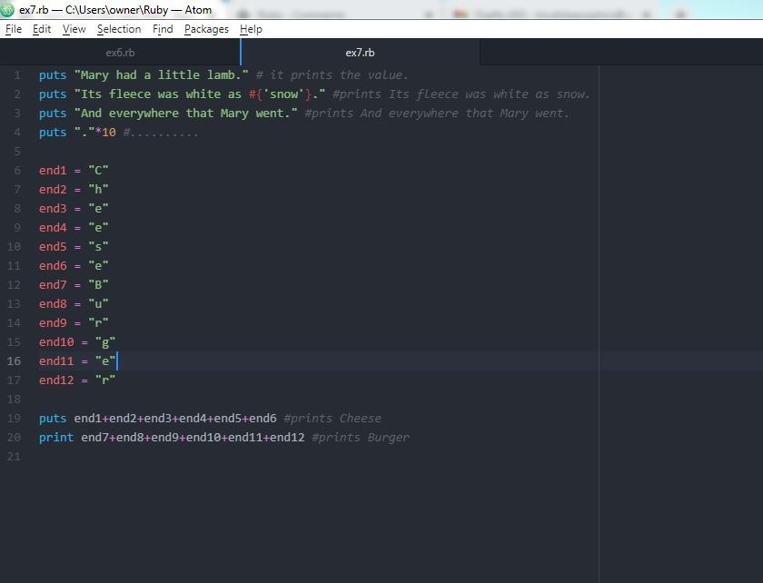

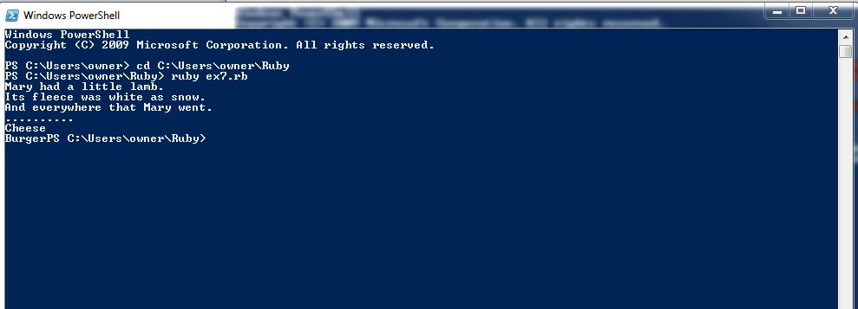

1. Read each one backward or out loud to find your errors.

**Done. There is no error.**

1. From now on, when you make mistakes, write down on a piece of paper what kind of mistake you made.

**Ya, I did.**

4. When you go to the next exercise, look at the mistakes you have made and try not to make them in this new one.

**Ok**